Connecticut Veterinary Medical Diagnostic Laboratory
University of Connecticut, Department of Pathobiology and Veterinary Science
61 N. Eagleville Road, Storrs, CT 06269

Admissions Office Come here first to speak with staff and fill out/submit paperwork

Client Parking Spaces
Please leave animal(s) in vehicle, then
continue to Admissions office for paperwork

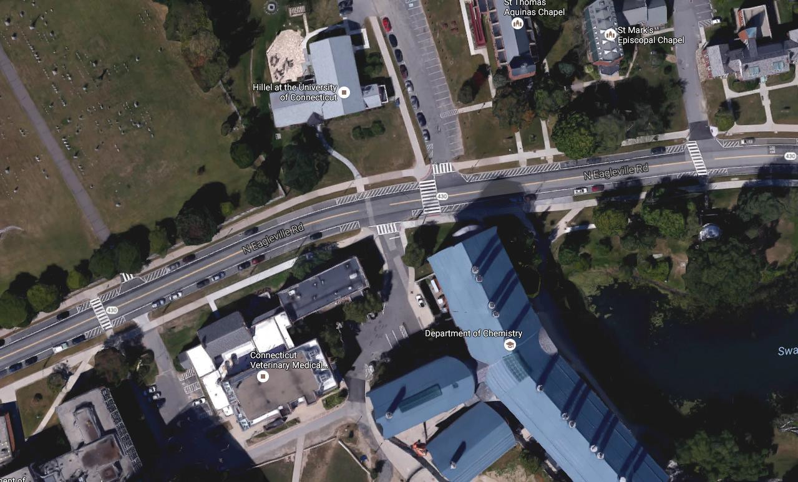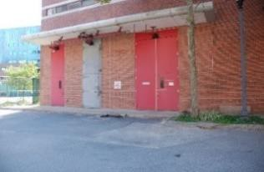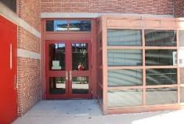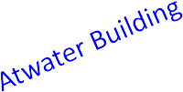

Additional Client Parking Spaces Please leave animal(s) in vehicle, then continue to Admissions office for paperwork

Deceased Animals Submitter should first go to the admissions office, then meet staff here to submit animal(s)

